LAB INDEX

NAME: Vivek Kumar SUBJECTNAME: Project Based Learning in Java Lab

UID: 21BCS8129 SUBJECTCODE: 20CSP-314

SECTION: WM-20BCS-616/A

|  |  |  |  |  |  |  |  |
| --- | --- | --- | --- | --- | --- | --- | --- |
| **Sr.No** | **Program** | **Date** | **Evaluation** | | | | **Sign** |
| **LW**  **(12)** | **VV**  **(10)** | **FW**  **(8)** | **Total**  **(30)** |
| 1 | Create an application to save the employee information using arrays. | 09-08-2022 |  |  |  |  |  |
| 2 | Design and implement a simple inventory control system for a small video rentalstore. | 23-08-2022 |  |  |  |  |  |
| 3 | Create a application to calculate interest for FDs, RDs based on certain conditions using inheritance. | 02-09-2022 |  |  |  |  |  |
| 4 | Create a program to show the usage of Sets of Collection interface. | 27-09-2022 |  |  |  |  |  |
| 5 | Create a program to set view of Keys from Java Hashtable. |  |  |  |  |  |  |
| 6 | Write a Program to perform the basic operations like insert, delete, display and search in list. List contains String object items where these operations are to be performed. |  |  |  |  |  |  |
| 7 | Create a menu based Java application with the following options.1.Add an Employee2.Display All3.Exit If option 1 is selected, the application should gather details of the employee like employee name, employee id, designation and salary and store it in a file. If option 2 is selected, the application should display all the employee details. If option 3 is selected the application should exit. |  |  |  |  |  |  |
| 8 | Create a palindrome creator application for making a longest possible palindrome out of given input string. |  |  |  |  |  |  |
| 9 | Create a Servlet/ application with a facility to print any message on web browser. |  |  |  |  |  |  |
| 10 | Create JSP application for addition, multiplication and division. |  |  |  |  |  |  |

## CHANDIGARH UNIVERSITY

## UNIVERSITY INSTITUTE OF NGINEERING

**DEPARTMENT OF COMPUTER SCIENCE & ENGINEERING**



|  |  |
| --- | --- |
| **Submitted By: Submitted To:**  Vivek Kumar(21BCS8129) Neeru Sharma(E12950) | |
| **Subject Name** | Project Based Learning in Java Lab |
| **Subject Code** | 20CSP-321 |
| **Branch** | Computer Science and Engineering |
| **Semester** | 5th |

**Experiment - 4**

**Student Name: Vivek Kumar UID: 21BCS8129**

**Branch: BE-CSE(LEET) Section/Group:20BCS-WM-616/A**

**Semester: 5th Date of Performance: 27/09/2022**

**Subject Name:** **Project Based Learning in Java Lab Subject Code: 20CSP-321**

**1. Aim/Overview of the practical:**

Create a program to show the usage of Sets of Collection interface.

**2. Task to be done/ Which logistics used:**

Write the program to create an application to perform a set manipulation.

**3. Software Requirements (For programming-based labs):**

* JDK-8 or any
* Eclipse-IDE for Java

**4. Steps for experiment/practical/Code:**

package unit2;

import java.util.*;

public class WorkSheet4 {

public static void main(String args[]) {

Set<Character> mySet1 = new HashSet<Character>();

mySet1.add('A');

mySet1.add('B');

mySet1.add('C');

mySet1.add('A');

mySet1.add('B');

System.out.println("\nmySet1: " + mySet1);

List<Character> list = new ArrayList<Character>();

list.add('A');

list.add('A');

list.add('B');

list.add('C');

list.add('B');

Set<Character> mySet2 = new HashSet<Character>(list);

System.out.println("\nlist: " + list);

System.out.println("\nmySet2: " + mySet2);

System.out.println("\nMySet1 matches mySet2: " + mySet1.equals(mySet2));

mySet2.remove('A');

System.out.println("\nmySet2: " + mySet2);

System.out.println("\nMySet1 matches mySet2: " + mySet1.equals(mySet2));

System.out.println("\nMySet1 contains all the elements: " + mySet1.containsAll(list));

System.out.println("\nMySet2 contains all the elements: " + mySet2.containsAll(list));

System.out.println("\nIterator Implementation");

Iterator<Character> iterator = mySet1.iterator();

while (iterator.hasNext()) {

System.out.println("Iterator loop: " + iterator.next());

}

System.out.println("\nFor loop Implementation");

for(Object str:mySet1) {

System.out.println("For each loop "+str);

}

mySet1.clear();

System.out.println("\nmySet1 is Empty: " + mySet1.isEmpty());

System.out.println("\nmySet1 has: " + mySet1.size() + " Elements");

System.out.println("\nmySet2 has: " + mySet2.size() + " Elements");

System.out.println("\nArray Conversion");

Object[] array = mySet1.toArray(new String[mySet2.size()]);

System.out.println("The array:" + Arrays.toString(array));

}

}

**5. Observations/Discussions/ Complexity Analysis:**

Here we have created the Set, list and Iterator and Data inserted, performed all the operation of set and Hashset.

**6. Result/Output/Writing Summary:**

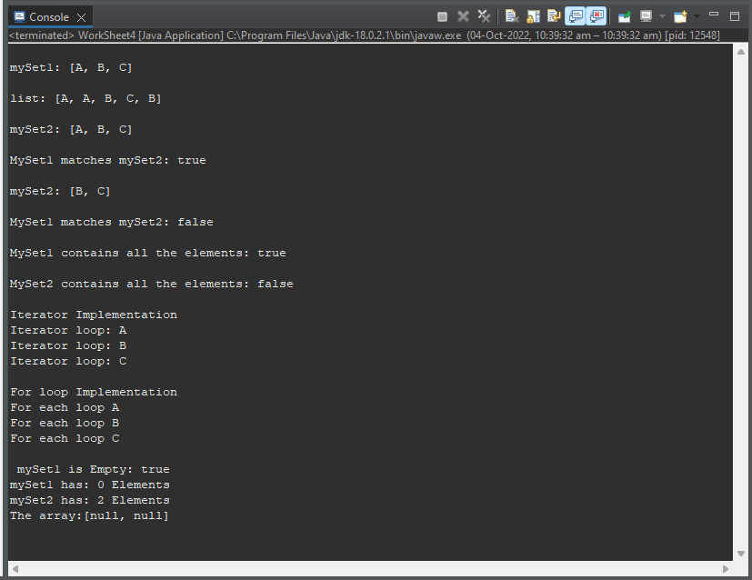

**Learning outcomes (What I have learnt):**

**1.** Learnt How to create the HashSet and insert the values to it.

**2.** Set manipulation concept understood.

**3.** Created list and Imported list in to a set.

**4.** Learnt the concept of Iterator.

**5.** Learnt concept of Set to Array Conversion

**Evaluation Grid (To be created per the faculty's SOP and Assessment guidelines):**

|  |  |  |  |
| --- | --- | --- | --- |
| Sr. No. | Parameters | Marks Obtained | Maximum Marks |
| 1. | Worksheet completion including writing learning objectives/Outcomes.  (To be submitted at the end of the day). |  |  |
| 2. | Post-Lab Quiz Result. |  |  |
| 3. | Student Engagement in  Simulation/Demonstration/Performance and Controls/Pre-Lab Questions. |  |  |
|  | Signature of Faculty (with Date): | Total Marks Obtained: |  |